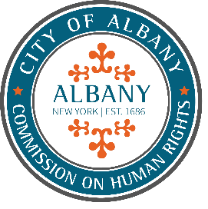
CITY OF ALBANY
COMMISSION ON HUMAN RIGHTS
CITY HALL
24 EAGLE STREET, ALBANY, NY
DR. DORCEY APPLYRS
MAYOR

MEETING NOTICE & AGENDA

Meeting Date: Monday, January 5, 2026
Meeting Time: 6:00pm
Location: Mayor’s Conference Room

Meeting Facilitator Thomas Mueller, Chair
Invitees Kimberly Young-Wilkins, Vice Chair
Kate Shelly, Secretary
Valerie Alexander-Moseley, Commissioner
Natisha Alexander, Commissioner
Celia Evers, Commissioner
Micaela Robinson, Commissioner
Melanie Woodward, Director of Employee Relations
Katrina Hodge, EEO Compliance Officer
Robert Magee, Executive Deputy Corporation Counsel

- Approval of December 1, 2025 Minutes
- Public Comment (limited to 5 minutes per person)
- Old Business
  - Update from NYS DHR meeting on December 11
- New Business
  - Presentation from the City of Albany Engineering Department
  - Presentation from the City of Albany Office of Human Resources
  - Presentation from the City of Albany Department of General Services
  - Confirm September 2026 and executive session CHR meeting dates and times
- Updates from Commission on Human Rights Subcommittees
  - Community and Non-profit Engagement and Events
    - Black History Month
    - Albany Law School Spring Panel
    - Human Rights Ceremony
  - Investigations
  - Communications and Social Media
  - Budget
- Other Announcements and Discussion
- Adjournment

